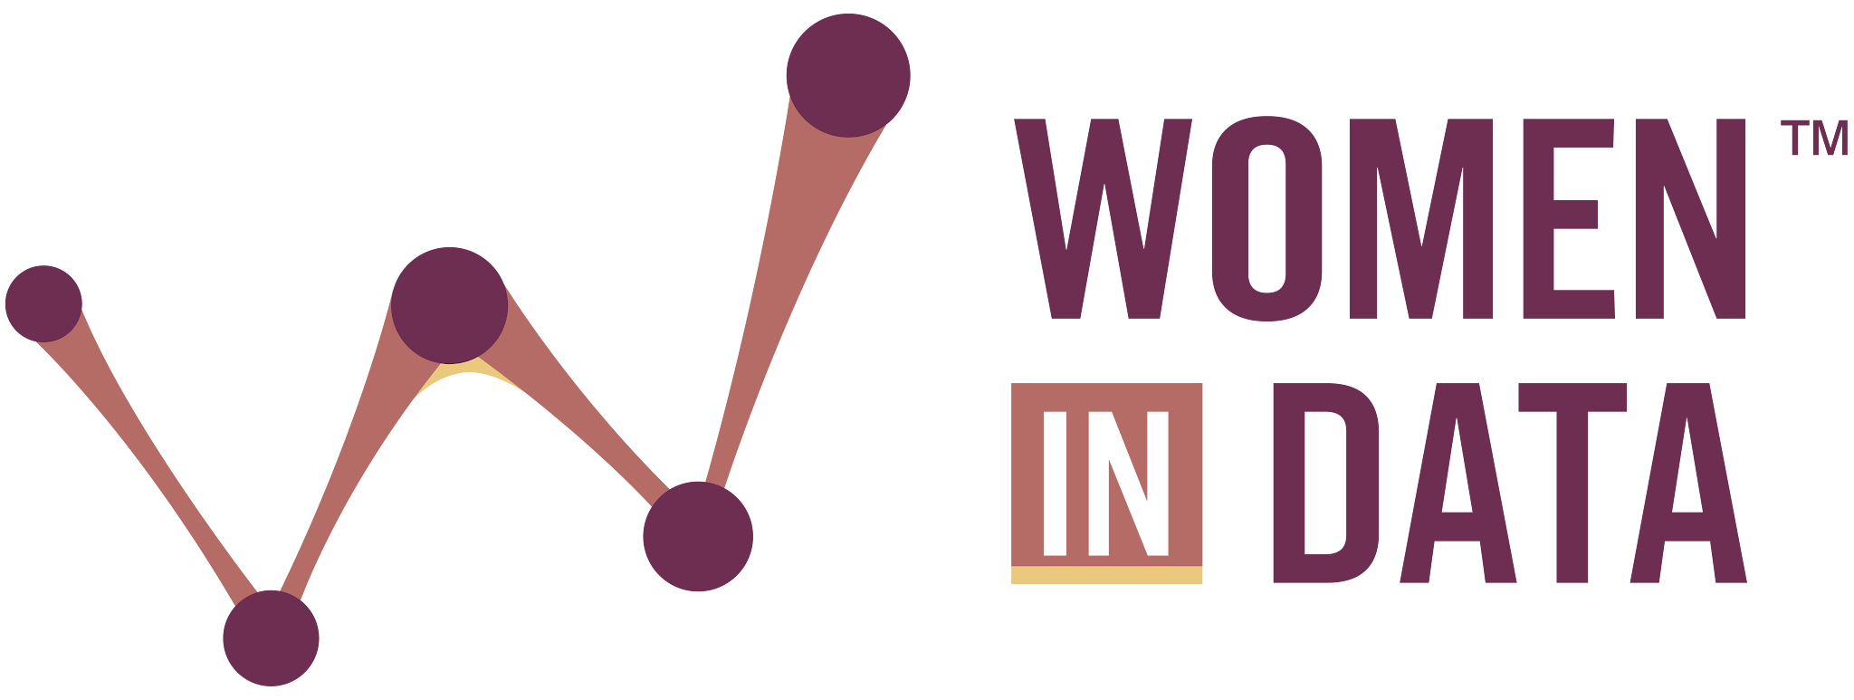
What’s Cooking?
From Farm to Fork . 2026 Datathon
Final Presentation Outline
Use this outline to structure your team’s video presentation. Your entire presentation must not exceed 7 minutes.
Team Introduction (45 seconds) - Sharon
- Introduce all team members (2–5 people).
- Briefly share your backgrounds and any relevant experience (e.g., data science, agriculture, nutrition, economics, sustainability, visualization).
- Name the track your project focuses on: Grow, Trade, Eat, or Sustain.
Problem Statement and Objectives (45 seconds) - Sharon
- Restate the Datathon’s main challenge: exploring the world’s food systems through data, from farm to fork.
- Define your team’s specific focus and the question you set out to answer (e.g., forecasting crop yields, mapping trade dependencies, closing a nutrition gap, reducing agrifood emissions).
- Identify the stakeholder(s) your project is intended to benefit (e.g., farmers, policymakers, supply-chain planners, public-health organizations, researchers).
Methodology and Approach (1.5 minute) - April
- Provide a high-level overview of your data sources (e.g., FAOSTAT datasets from the UN Food & Agriculture Organization).
- Explain how you accessed and analyzed the data (mention tools like the FAOSTAT API, Python, R, Jupyter, or visualization libraries).
- Describe your workflow: from data acquisition to cleaning, processing, and analysis.
- Briefly mention any obstacles you encountered and how your team addressed them.
Key Findings and Insights (2 minutes) - Sandra
- Share the most important findings from your analysis.
- Use visualizations to showcase:
  - Trends and patterns across regions or over time
  - Comparisons, correlations, risk assessments, or forecasts
  - Insights that could improve food security, nutrition, trade resilience, or sustainability
- Highlight any unexpected or significant discoveries that emerged from your work.
Solution or Tool Highlights (1 minute) -Toni
- Summarize your project deliverable (e.g., prototype dashboard, predictive model, report, or data story).
- Emphasize how your solution contributes to a healthier, more equitable, or more sustainable food system.
- Discuss its potential applications, scalability, or ethical considerations.
- If applicable, describe how your work improves accessibility or understanding of complex food data.
Recommendations and Next Steps (45 seconds) - Toni
- Offer actionable recommendations based on your project. These may include:
  - Strategies for strengthening food security or nutrition
  - Making food and agriculture data more usable for decision-makers or the public
  - Enhancing collaboration among global food-system stakeholders
- Suggest future enhancements, research directions, or data needs.
Conclusion (15 seconds) - Toni
- Recap your core takeaways in one or two powerful statements.
- Re-emphasize the potential impact of your work on the future of food systems and our planet.

Note: Your entire presentation must not exceed 7 minutes. Practice delivering your content clearly and confidently within the time limit.

